NovaTrust Bank
Performance & Profitability Analysis
Google sheets, SQL (postgreSQL), Power BI
Ibirogba Abiodun Isaac

1a. Data Model
The dataset follows a star-schema structure made up of one central fact table (transaction) and three supporting dimension tables (customer, branch, and product). The fact table stores every individual transaction event and links out to each dimension table through a foreign key, which allows revenue, profit, and volume to be sliced by customer, branch, and product attributes.
Table | Role | Key Field(s) | Relationship
customer | Dimension table | customer_id (PK) | One customer can have many transactions (1-to-many with transaction.customer_id)
branch | Dimension table | branch_id (PK) | One branch can process many transactions (1-to-many with transaction.branch_id)
product | Dimension table | product_id (PK) | One product can appear in many transactions (1-to-many with transaction.product_id)
transaction | Fact table | transaction_id (PK); customer_id, branch_id, product_id (FKs) | Each transaction row references exactly one customer, one branch, and one product
Relationship diagram
customer (1) → (∞) transaction (∞) ← (1) branch, with transaction (∞) → (1) product

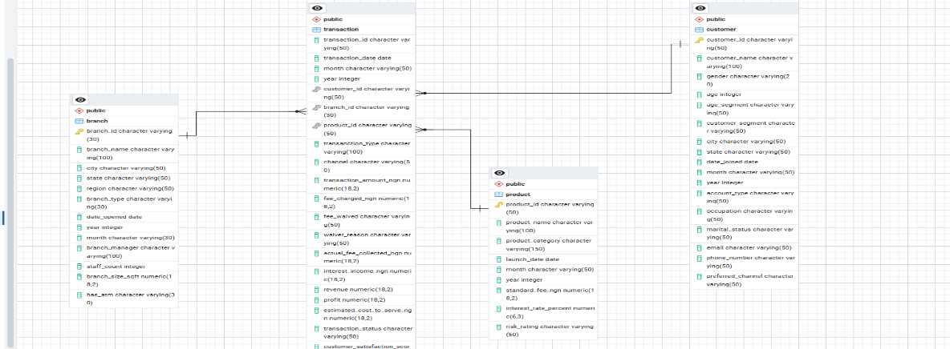
Each relationship is one-to-many: a single customer, branch, or product can be associated with many transactions, but each transaction belongs to exactly one customer, one branch, and one product. This design avoids data duplication in the dimension tables and keeps all measures (revenue, profit, fees, interest income) at the transaction (fact) level, which is best practice for reporting and aggregation.

1b. Analysis Process
The analysis followed a structured pipeline from raw data to a finished dashboard, moving through Google Sheets, PostgreSQL (SQL), and Power BI.

Step 1: Data Understanding & Receipt
On receiving the raw dataset, I first reviewed its structure to understand what each column represented, identified the four logical entities (customers, branches, products, and transactions), and checked for obvious quality issues such as inconsistent text casing, blank cells, and mixed date formats before any cleaning began.

Step 2: Data Cleaning (Google Sheets)
All initial cleaning was performed in Google Sheets before the data was exported for database loading. Activities carried out included:
- Trim: removed leading/trailing and extra internal whitespace from text fields.
- Proper casing: standardized text fields (e.g., names, cities) to consistent capitalization.
- Find & Replace: corrected inconsistent labels, typos, and duplicate spellings of the same category.
- Data type formatting: ensured numeric, date, and text fields were formatted consistently.
- Naming convention: renamed all column headers to snake_case (e.g., customer_id, transaction_date) to match SQL naming standards.
- Formatted the range as a table for easier filtering and validation during cleaning.
- Removed unnecessary/redundant columns that added no analytical value.
- Created new derived columns: month, year, age_segment, revenue, and profit, calculated from existing raw fields.
- Exported the cleaned data as CSV files (one per entity: customer, branch, product, transaction) ready for import into PostgreSQL.

Step 3: Database Design & Load (SQL / PostgreSQL)
The cleaned CSVs were loaded into a PostgreSQL database structured as a relational star schema:
- Created four tables: customer, branch, product, and transaction, with appropriate columns.
- Defined branch_id and product_id as primary keys using ALTER TABLE ... ADD CONSTRAINT, and customer_id as the primary key of the customer table.
- Added foreign key constraints on the transaction table (fk_transaction_customer, fk_transaction_branch, fk_transaction_product) to formally link the fact table to each dimension table.
- Validated each table on load with SELECT * queries to confirm row counts and spot-check values.
- Converted columns from their initial VARCHAR/text state into proper data types i.e DATE, INTEGER, and NUMERIC, using ALTER TABLE ... ALTER COLUMN ... TYPE ... USING, combined with NULLIF to safely handle blank values and TO_DATE to parse date strings (format DD/MM/YYYY).

Step 4: Calculations Created
In SQL, calculations were built directly into the analysis queries using aggregate functions and a window function:
- SUM(revenue) and SUM(profit): total revenue and profit by branch, segment, and waiver status.
- COUNT(transaction_id): transaction volume by branch and by product.
- ROUND(AVG(revenue), 2) / ROUND(AVG(profit), 2): average revenue and profit per transaction.
- LAG(monthly_revenue) OVER (ORDER BY year, month): prior month's revenue, used to compute month-over-month (MoM) growth percentage: (current - previous) / previous × 100.
- A CASE WHEN fee_waived = 'Yes' THEN 'Waived' ELSE 'Not Waived' END grouping to compare profitability with and without fee waivers.

In Power BI, the following DAX measures were built on top of the model: Total Revenue, Total Profit, Total Transaction Volume, Total Customers, Total Branches, Total Products, Fee Waived Amount. A dedicated Date table was also created with Year, Quarter, Month, and Weekday columns to support time-based filtering and the revenue trend visual.

Step 5: Analysis Techniques Used
- Aggregation and grouping (GROUP BY) to summarize revenue, profit, and volume by dimension.
- Joins across the fact and dimension tables to bring branch, customer, and product attributes into the transaction-level analysis.
- Window functions (LAG) for period-over-period trend and growth-rate analysis.
- Comparative analysis (waived vs. not waived fees) to isolate the profitability impact of a specific business policy.
- Time-series analysis of monthly revenue to assess growth, stability, or decline.

Step 6: Dashboard Development Process (Power BI)
- Loaded the cleaned data into Power BI and used Power Query to transform and shape it further where needed.
- Built the data model, connecting customer, branch, and product to transaction via one-to-many relationships (mirroring the SQL foreign keys).
- Created the DAX measures and the Date table described in Step 4.
- Selected and built visuals matched to each business question: a bar chart for revenue by branch, a line chart for the revenue trend over time, a doughnut chart for revenue by customer segment, a column chart for profit by fee-waived status, and a bar chart for transaction volume by product.
- Formatted the report page (titles, colors, data labels, tooltips) and added slicers/filters for interactivity.
- Cross-checked the totals shown on each visual against the equivalent SQL query results to validate accuracy before finalizing the dashboard.

2a. Dashboard
The Power BI dashboard below answers each of the five business questions defined during the SQL analysis phase.

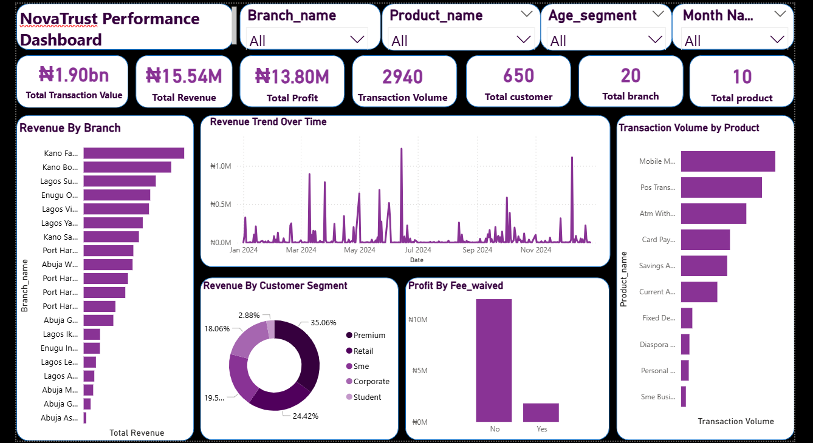

2b. Dashboard Explanation

What each visual represents and how it answers the business questions
Visual | What it Represents | Business Question Answered
Total Revenue by Branch (Bar Chart) | Total revenue generated by each branch, ranked from highest to lowest. | Q1: Which branch generates the highest revenue, and how does branch performance compare across the bank?
Revenue Trend Over Time (Line Chart) | Monthly revenue plotted across the Date table's timeline. | Q4: Is monthly revenue growing, stable, or declining over time?
Revenue by Customer Segment (Doughnut Chart) | Share of total revenue contributed by each customer segment. | Q2: Which customer segment contributes the most revenue, and which contribute the least?
Profit by Fee-Waived Status (Column Chart) | Total profit split between transactions where fees were waived vs. not waived. | Q5: How do fee waivers affect profitability?
Transaction Volume by Product Name | Number of transactions recorded per banking product. | Q3: Which banking product records the highest transaction volume?

Key insights identified
- Branch performance: Kano Fagge Branch generated the highest total revenue at #1,887,353.73, while Abuja Asokoro Branch recorded the lowest at #49,930.95, indicating a performance gap of #1,837,432.78 between the two branches and 37.80 multiplier gap.
- Customer segments: The premium segment contributed the largest share of revenue 35.06%, while student contributed the least, suggesting an opportunity to grow underperforming segments and count drill down analysis on how to improve student segment revenue performance.
- Product performance: Mobile Money Transfer recorded the highest transaction volume with 686 transactions, showing it is the bank's most frequently used product.
- Revenue trend: Monthly revenue increased at some point, decreased in others and stayed flat over the period analyzed, with the strongest month-over-month growth in March, June and December, and the sharpest decline in July and August.
- Fee waivers: Waived-fee transactions accounted for #11,331,211.42 in forgone revenue but transactions volume showed lower average profit per transaction than non-waived transactions, indicating the reduction in profit by waived fee.

3. Recommendations
Based on the analysis process and the structure of the findings above, the following recommendations are proposed to help NovaTrust Bank improve performance, profitability, and decision-making. Each should be validated against the specific figures from your completed dashboard.

Performance
- Study the operating practices of the top-performing branch(es) staffing levels, product mix, channel usage and use them as a model to coach lower-performing branches.
- Set branch-level revenue and transaction-volume targets informed by the average revenue per transaction benchmark identified in the analysis.

Profitability
- Review the fee-waiver policy: if waived transactions are not translating into materially higher customer value or retention, tighten waiver eligibility criteria or cap waiver amounts by customer segment.
- Promote the products with the highest revenue-per-transaction (not just highest volume) to improve overall profit margin, not just transaction counts.
- Investigate any months with declining month-over-month revenue growth to identify root causes (seasonality, product issues, branch disruptions) and build mitigation plans ahead of similar periods.

Customer Strategy
- Design targeted offers or loyalty incentives for the highest-contributing customer segment to protect and grow that revenue base.
- Develop a growth plan (cross-selling, tailored products, engagement campaigns) for the lowest-contributing segment so as to expand their share of revenue.

Decision-Making & Reporting
- Adopt the Power BI dashboard as a recurring (weekly/monthly) reporting tool for branch and product performance reviews, rather than a one-off analysis.
- Maintain the SQL data pipeline (cleaning → typed tables → validated joins) as the single source of truth feeding the dashboard, so figures stay consistent across teams.
- Extend the model with additional dimensions (e.g., channel, device type, customer satisfaction score) in a future iteration to uncover deeper drivers of profitability and customer experience.

Appex
SQL Queries,execution and results for the business question